15. Handing database exceptions and error condition.
use DBMT13;
create TABLE employees8(
id INT PRIMARY KEY,
name VARCHAR(100)
);
CREATE TABLE errorlog (
id INT AUTO_INCREMENT PRIMARY KEY,
error_message VARCHAR(255),
error_time DATETIME
);
DELIMITER //
CREATE PROCEDURE InsertEmployeeSafe(
IN emp_id INT,
IN emp_name VARCHAR(100))
BEGIN
DECLARE CONTINUE HANDLER FOR SQLEXCEPTION
BEGIN
INSERT INTO errorlog(error_message, error_time)
VALUES (
'Error occurred while inserting employee',
NOW());
END;
INSERT INTO employees8(id, name)
VALUES (emp_id, emp_name);
END //
DELIMITER ;
CALL InsertEmployeeSafe(1, 'John');
SELECT * FROM employees8;
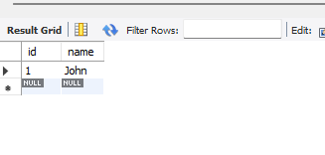
CALL InsertEmployeeSafe(1, 'Mike');
SELECT * FROM errorlog;
